UML diagrams

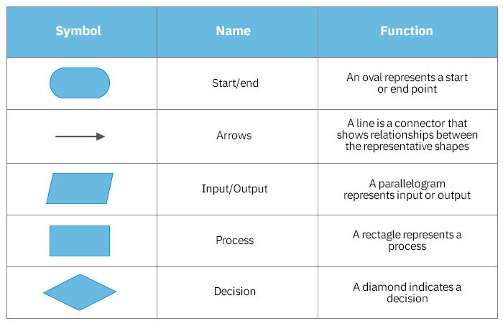

 each flowchart symbol individually.

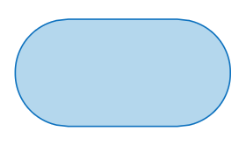

**Start/End Symbol**

The terminator symbol marks the starting or ending point of the system. It usually contains the word "Start" or "End."

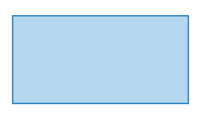

**Action or Process Symbol**

A box can represent a single step ("add two cups of flour"), or an entire sub-process ("make bread") within a larger process.

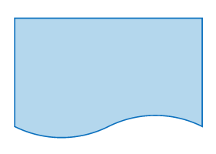

**Document Symbol**

A printed document or report.

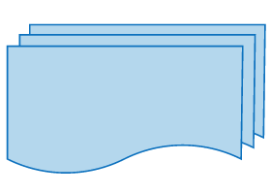

**Multiple Documents Symbol**

Represents multiple documents in the process

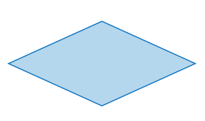

**Decision Symbol**

A decision or branching point. Lines representing different decisions emerge from different points of the diamond.

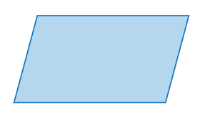

**Input/Output Symbol**

Represents material or information entering or leaving the system, such as customer order (input) or a product (output).

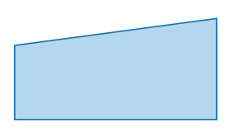

**Manual Input Symbol**

Represents a step where a user is prompted to enter information manually.

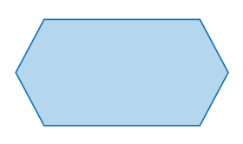

**Preparation Symbol**

Represents a set-up to another step in the process.

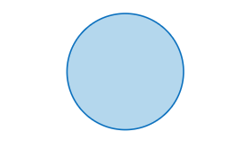

**Connector Symbol**

Indicates that the flow continues where a matching symbol (containing the same letter) has been placed.

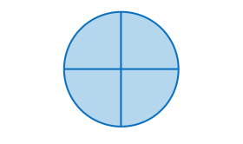

**Or Symbol**

Indicates that the process flow continues in more than two branches.

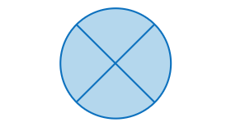

**Summoning Junction Symbol**

Indicates a point in the flowchart where multiple branches converge back into a single process.

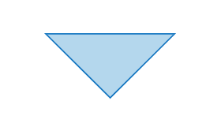

**Merge Symbol**

Indicates a step where two or more sub-lists or sub-processes become one.

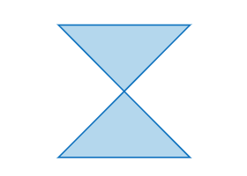

**Collate Symbol**

Indicates a step that orders information into a standard format.

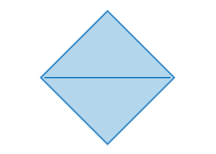

**Sort Symbol**

Indicates a step that organizes a list of items into a sequence or sets based on some pre-determined criteria.

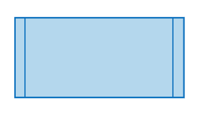

**Subroutine Symbol**

Indicates a sequence of actions that perform a specific task embedded within a larger process. This sequence of actions could be described in more detail on a separate flowchart.

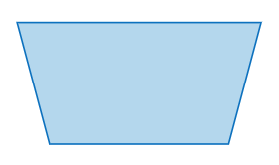

**Manual Loop Symbol**

Indicates a sequence of commands that will continue to repeat until stopped manually.

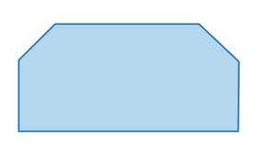

**Loop Limit Symbol**

Indicates the point at which a loop should stop.

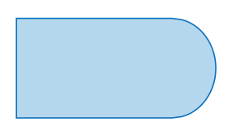

**Delay Symbol**

Indicates a delay in the process.

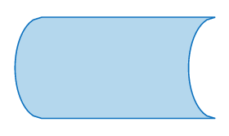

**Data Storage or Stored Data Symbol**

Indicates a step where data gets stored.

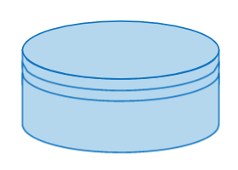

**Database Symbol**

Indicates a list of information with a standard structure that allows for searching and sorting.

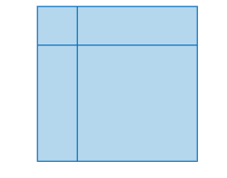

**Internal Storage Symbol**

Indicates that information was stored in memory during a program, used in software design flowcharts.

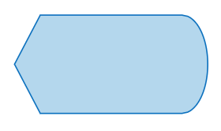

**Display Symbol**

Indicates a step that displays information.

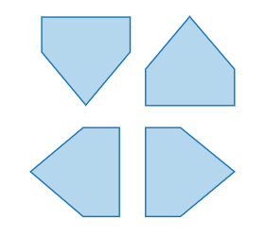

**Off Page**

Indicates that the process continues off page.